This checklist is intended to assist everyone at UWRF in planning events, public consultations, celebrations, and other occasions to be equally accessible and inclusive to all students and community members with a disability.
Accessibility Checklist for Events

Disability Etiquette:
Do not assume an individual needs assistance. When interacting with someone, use the Approach, Ask, Assist Method:
- Approach: If you suspect someone may need a hand, walk up, greet them, and identify yourself.
- Ask: "Would you like some help?" The person will accept your offer or tell you if they don't require assistance.
- Assist: Listen to the reply and assist as requested. Don't be offended if your assistance is not needed.
Some other vital concepts include:
- Talking directly to the individual, not the interpreter, companion, or attendant.
- Listen carefully and wait to reply until the individual has finished speaking, be sensitive about physical contact and space.
- Do not decide on behalf of a person with a disability regarding what they can/cannot do.

General Information on Service Animals:
Service animals are permitted to accompany their handler into any event space. Under the
Americans with Disability Act (ADA) defines a service animal as an animal that has been individually trained to do work or perform tasks for an individual with a disability. The ADA does not require service animals to wear a vest, tag, specific harness, or have any specific certification. In situations where it is not apparent that the dog is a service animal, staff may ask only these two questions:
- Is the animal required because of a disability?
- What work or task has the dog been trained to perform?
You are not allowed to request any documentation for the animal, require that the animal demonstrate its task, or inquire about the nature of the person's disability.
Promotion and Advertising:
Digital Flyers:
- Ensure documents are physically and digitally accessible. (E.g., color contrast on document and font size (size 14-16 font when printed).
- Disclose warnings for strobe lights,seizure-sensitive lighting, and any smells.
- Ensure all event flyers contain the required accommodation notification information:
  - Individuals with disabilities are encouraged to attend the University of Wisconsin-River Falls-sponsored events. If you require any accommodations to participate in this event, don't hesitate to contact the Disability Resource Center at drc@uwrf.edu
Social Media:
- Include image descriptions.
- Include closed captions on any videos.

Event Location:
- Ensure transportation options for getting to the venue. If you take a bus or the campus van, ensure room for mobility aids/medical equipment.
- Communicate ahead of time to the participants about event details (location, food, and travel arrangements).
- If your event is on an upper floor, ensure a working elevator is available.
- Ensure the event space has a designated accessible restroom.
Event Seating:
The number of Required Wheelchair Spaces for Assembly Areas (Per ADA):
- 4-25 Seats -1 Spaces
- 26-50 Seats- 2 Spaces
- 51-150 Seats- 4 Spaces
- 151-300 Seats- 5 Spaces
- 301- 500 Seats- 6 Spaces
- Every wheelchair space must have a companion seat adjacent to it.
Seating Considerations:
- Request extra space between tables/chairs if there is an interactive part of the event.
- Must be on an accessible route that provides access to restrooms, buffet lines, exit, etc.
- Check the line of sight so there are no obstructions.
- Electrical outlets to accommodate adaptive devices.
- Complete an overflow plan in case there are more accessible seats needed.

Event Access:
- To create an inclusive setting for folks with mental health conditions, ADHD, Autism, etc., Encourage presenters/event hosts to set some welcoming expectations for everyone in that space. For example, at Disability Led conferences, presenters usually say, “Everyone comes to this space in their own way. If you need to take a break, stretch, or stim, we welcome you to do what you need.”
- Provide signage to the locations of the elevators or the closest accessible and gender-neutral restrooms.
- The retractable barriers are at least 36 inches apart so mobility aids can turn.
Video
- Choose materials that enable closed captions.
- Know ahead of time how to access closed captions.
- If requested, know how to access audio descriptions.
Speeches and Presentations:
- Type text at least size 14 and avoid decorative fonts.
- If a request is made for large print, it should be a font size of 18 or larger.
- Avoid using italics or all capital letters.
- Spell out numbers.
- Check color contrast on slides (avoid dark backgrounds with a dark print and light backgrounds with light fonts)
- Add patterns to colors to convey meaning in charts & graphs.
Communication Considerations for Presenters:
- Announce the start and end of the presentation.
- Verbally describe visual materials (slides, charts, etc.)
- Use a roving microphone for the audience to ask questions. Repeat questions posed by participants in the audience before responding. If a microphone is unavailable, the presenter should repeat the question before answering.
- When addressing someone, specifically ask for his/her/their name and pronouns.
Food Considerations:
- If possible, allow participants to indicate any dietary needs beforehand.
- If possible, attempt to have a gluten-free, dairy-free, and vegan option on top of the main dish.
- Communicate on marketing materials about what food is being offered.
- Indicate allergen and gluten-free, vegan, vegetarian, or other options.
Resource, Definitions, & Guides:
Image description:
A detailed explanation of an image that provides textual access to visual content; can be used for digital graphics online and in digital files or at larger presentations so the audience knows who the speaker is.
- Poster Guide:
  - Write “Image Description.”
  - Describe the color and background of the poster.
  - Type out what the poster states.
Example:
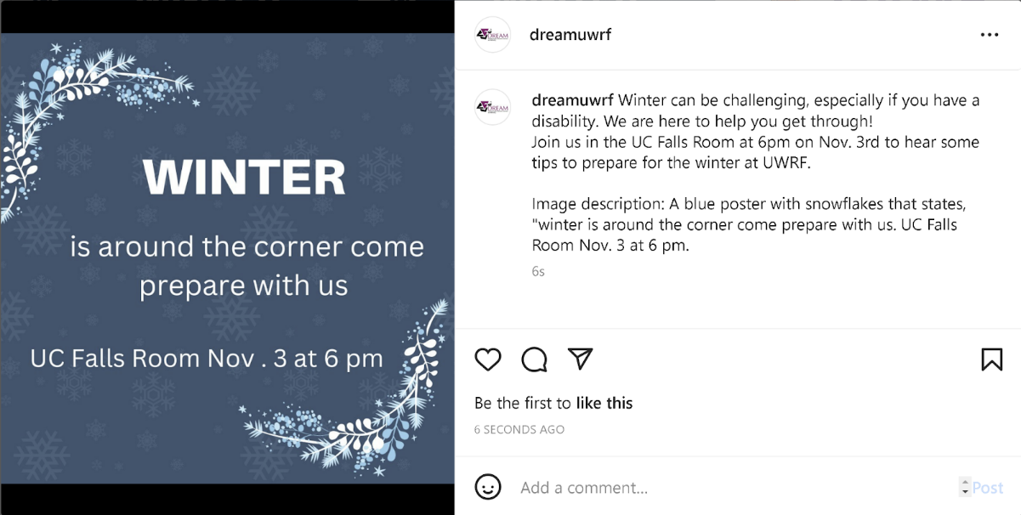
- Image Guide:
  - Write “Image Description:”
  - Who is in the picture?
    - It doesn't have to be specific (a person, two students, a group of students)
  - Describe the location and what the people are doing.
Example:
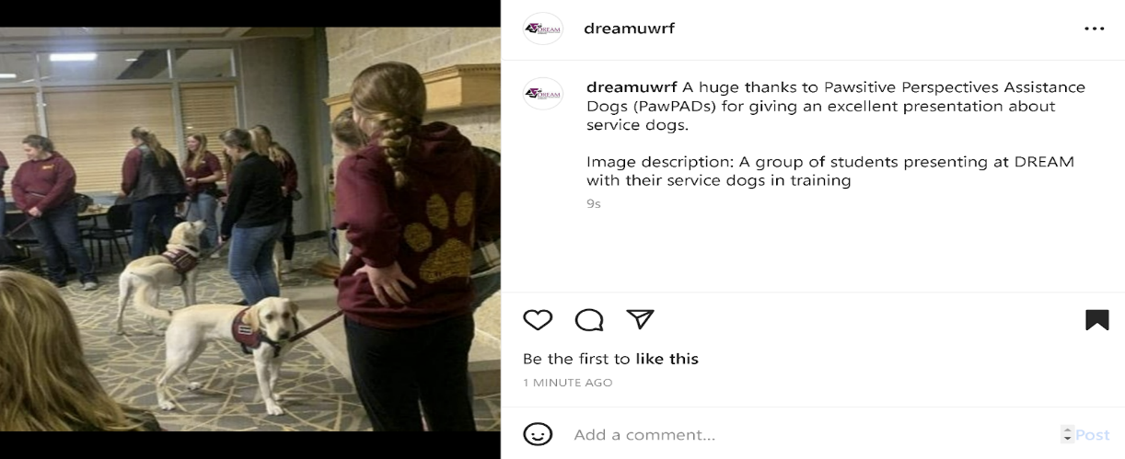

Closed Captioning:
Turns video audio into text on a screen.
- Instagram Stories/ Reels Guide:
  - Upload an Instagram Story or reel.
  - In the editor mode, swipe up to the section where you usually find polls, stickers, location tags, and hashtags (As seen in picture one).
  - Select ‘captions.’ (As seen in picture two)
  - Instagram will automatically transcribe the audio, which you can click to edit or change the color and font of the text.
  - Select done, resize the text how you’d like it, and you’re finished.
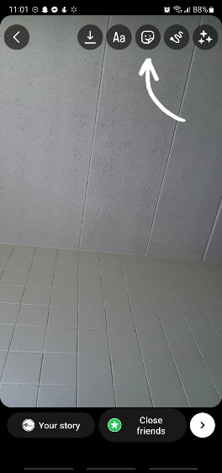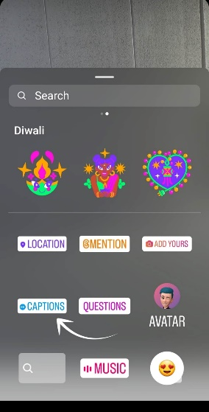
(Picture One) (Picture Two)
Resources:
- The ADA standards for Accessible Design
  - ADA Is a civil rights law prohibiting discrimination against individuals with disabilities. The standards set minimum requirements for public accommodations and facilities to ensure it is usable by disabled individuals.
    - Website: https://www.ada.gov/law-and-regs/design-standards/2010-stds/
- Disability Resource Center:
  - Can assist with any questions about programming accommodations.
    - Phone: 715.425.0740
    - Email: drc@uwrf.edu
    - Website: https://www.uwrf.edu/DRC/
- Disability Rights Education Activism Mentoring:
  - A registered Organization on campus that is disability centered and can offer any assistance with programming accommodations.
    - Email: Dream@uwrf.edu

