
How To: Check-In Students at Events
- On your phone, download the “Corq” and “Campus Labs Event Check-in” apps from the app store
=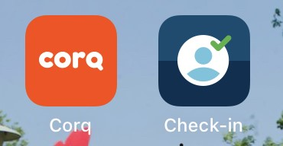
- Go to FalconsConnect on your computer and click “Sign-In”
- Sign in with your W number
- Click your Department on the lefthand side and click “Events”
- Choose the event, make sure it is the correct date/time
- Find the event access code
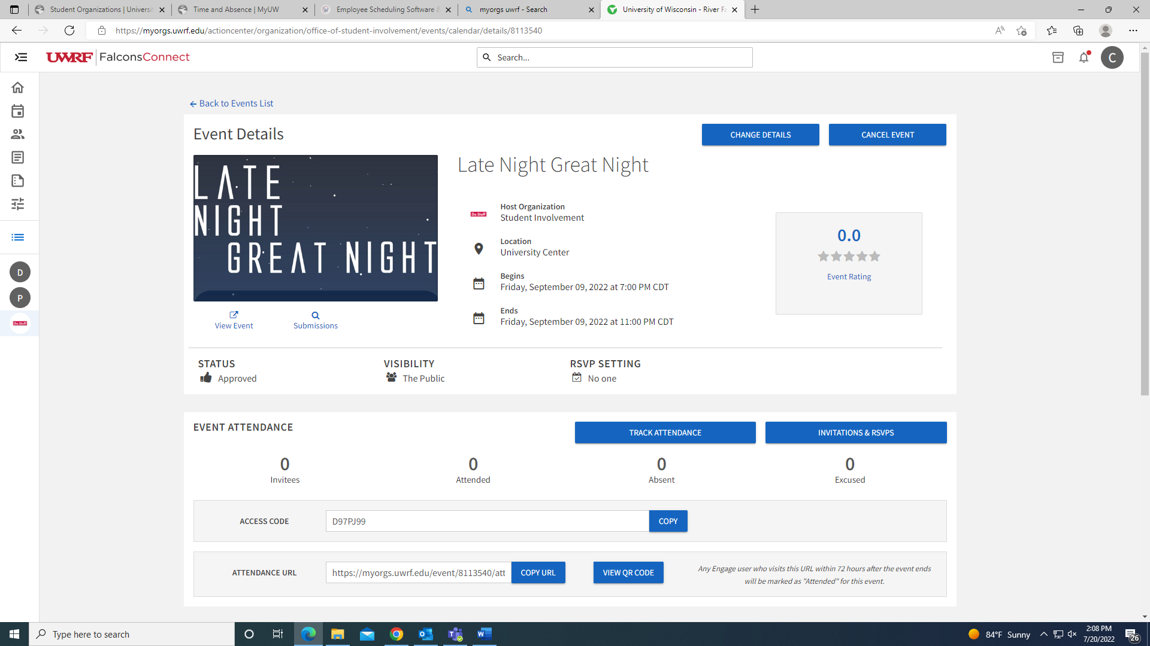
- Go back to your phone, select the event check-in app, and sign in with your W-number
- Enter FalconsConnect access code into the event check-in app
- Select “Scan” tab at bottom of check-in app to scan the student’s QR Code OR select “Search” tab to search for student’s name/email/W# (if no Corq)
- When the student pops up, select “Check In.” Successful check-ins should have a little green arrow 😊

